WASHINGTON COUNTY DEMOCRATIC CONVENTION
Saturday MARCH 23, 2019 2:00 p.m.
AGENDA
1:30-2:00 Sign-in and Name tags and Requests for delegate nominations
2:00 Welcome, Officer introductions and Call meeting to order and Approve agenda - Chuck Goode
2:05 Pledge of Allegiance and What we stand for "Reading of the County Platform"
2:10 Review of Washington County Democratic Party accomplishments - Lynne Cobb, Secretary
2:15 Treasurer's Report for 2018 and 2019 Budget Recommendations and Donations - Glenn Justice
2:20 Approval of 2019 Budget and of new Delegates - Chuck Goode and Lynne Cobb, Parliamentarian
2:25 Report on 2018 Local Campaigns and Approach for 2020 - Collin Weiss, Vice-Chair
2:30 Dixie State University College Dems update - Abby Doman, President
2:35 Update on Environmental Issues - Robert Ford, 2018 Candidate for County Commission
2:45 Update on Medicaid Expansion - Chuck Goode, 2018 Candidate for State House
2:50 Update on Immigration Issues - Megan Honer-Orton, Zion Corridor District Leader with Bre Baker
Reading of the Utah Compact - Chuck Goode
2:55 Charles Stormont, State Committeeman, Past Candidate for Attorny General - State Party update
3:00 Q Dang, Salt Lake County Chair, Candidate for State Chair - Rural connection & Communications
3:05 DOROTHY ENGELMAN: Keynote Address: "Find Your Passion, Find Your Voice and Run", . Past Party Chair, Winner of Taylor/Mayne Award, Past Member of the State Executive Committee
3:20 Election of Officiers for 2019-2021 - Chuck Goode, Chair
3:25 Upcoming events
3:30 Adjourn
CONTACT INFORMATION FOR OFFICERS OF THE WASHINGTON COUNTY DEMOCRATIC PARTY
Washington County Democratic Party of Utah
PO Box 774, St George, Ut 84771
Website: WCDPU.COM Phone: 435-339-0200
Email: chair@thewashingtondems.com

WASHINGTON COUNTY DEMOCRATIC PARTY PLATFORM
This platform was approved by Washington County Democratic Party Delegates at the April 7, 2018 convention
PREAMBLE
As Democrats, we believe that our country’s greatest strength is its people, and we are committed to the values of inclusion, equality and justice for all. We are a “big tent” party that embraces diversity and is open to everyone. We recognize that each person brings their own experience, perspective, and priorities to the Party and the platform is organized alphabetically, rather than by importance, in recognition of that diversity.
ANIMAL RIGHTS
Utah is one of the worst states in protections for animals, and we can and must do better. Our treatment of animals reflects on the morality of our society, and we call for immediate improvements to the welfare of animals used in agriculture and research, as well as those kept as companions. We call for stronger shelter requirements for animals left outdoors in Utah’s harsh winters and summers, and we categorically oppose Utah’s unconstitutional, non-content-neutral “ag-gag” statute. The state must provide more resources to humanely reduce and end Utah’s homeless pet problem, including outreach beyond the state borders and transport support. We further recognize that without a vigorous spay/neuter policy, including no or low cost option, that problem will continue. We support the passage of the Preventing Animal Cruelty and Torture (PACT) Act and further legislation to strengthen the federal and state Animal Welfare Acts.
ARTS
Washington County Democrats believe that art is vital. It represents the best of us and is an embodiment and spirit of our hopes, dreams, and creativity. Art serves to strengthen communities and is one of the best ways for cultural and historical connection. We strongly support funding, encouraging, and advancing the arts and arts education.
CHILDREN
Washington County Democrats believe that public investments in our children is paramount to the survival of our nation. Every child deserves to be cared for, educated, and protected; therefore, we oppose deportations that separate families. We strongly support those actions and incentives which:
- Ensure a strong emphasis on education fundamentals
- Emphasize learning how to think critically
- Keep them safe while they learn and grow
- Provide the necessary nutritional basis to ensure growth into healthy, functional adults

Accordingly, we advocate an integrated public education for children, including universal preschool/childcare and strong early childhood education, including after school and summer learning programs. These programs are vital to balanced development while providing safe, nurturing environments, as well as reducing future expenditures to address social dysfunction. We stand for equal funding per student, regardless of ZIP code.
CIVIL RIGHTS
Washington County Democrats strongly affirm that civil rights are about people and equality for all and uphold those freedoms established by the United States Constitution. We further resist pervasive and disgraceful attacks upon them. Accordingly, we:
- Understand that the right to privacy is intrinsic to the Fourth Amendment and oppose mass collection of data and metadata
- Oppose government spying on U.S. citizens
- Recognize that the separation of church and state is enshrined in the Constitution and paramount to the success of the United States
- Reject that religious freedom grants any license to discriminate in government, public life, employment, or housing
- Support the right to petition
- Oppose “free speech zones,” including those that corral protesters
CLIMATE CHANGE
Washington County Democrats stand for responsible stewardship of the environment. We strongly affirm the overwhelming consensus of climate scientists that human-caused climate change is an urgent crisis threatening our future. We support efforts to lessen and reverse the current climate trend by ambitious and immediate efforts to substantially cut emission of greenhouse gases and develop clean energy incentives to wean Utah off of fossil fuels in favor of clean alternatives, such as wind or solar. We also support fighting terrorism, through energy security and energy independence via 100% energy renewable resources.
CRIMINAL JUSTICE REFORM
Washington County Democrats oppose the privatization of prisons and affirm that the primary goals of incarceration should be successful rehabilitation and return to society. Therefore, we support:
- Expanding job training and education opportunities for the incarcerated
- Reducing recidivism
- Development of programs aimed at deferring youth from juvenile incarceration, ending the school-to-prison pipeline
- Decriminalization of addiction
- Legislation to “ban the box” requiring disclosure of prior felony convictions on job applications
- Promote access to subsidized housing for persons with criminal history
- Funding and expanding substance abuse treatment in jails, prisons and the community

CYBERSECURITY
Washington County Democrats strongly believe that cyber-security is one of the largest issues facing the world today and will only continue to grow in the future. We support:
- Initiatives, incentives and programs to educate citizens on how to protect themselves from cyber-attacks
- The implementation of software and hardware solutions that will protect federal and state governments from criminal and foreign state actors
- A balanced approach to legislation that maintains the right to privacy while allowing for the prosecution of cyber criminals
- The protection of citizens from government collection of digital communications and searches of electronic devices
- To support state legislation that will provide Utah citizens with a lawful and anonymous path to report to law agencies and relevant parties when they come into the knowledge of security flaws.
- To support and encourage transparency from Federal companies when their security has been compromised and confidential information has been taken

DISABILITY
Washington County Democrats are dedicated to ensuring that people with disabilities are enabled to participate in all aspects of society. We understand while many disabilities are visible, many more are invisible including neurodiversity and mental health issues. All people within the full spectrum of disabilities deserve full access, inclusion, and equality. We support bipartisan partnerships to meet these goals. Therefore, Washington County Democrats support:
- Full promise and enforcement of the Americans with Disabilities Act (ADA), the Fair Housing Act, Individuals with Disabilities Education Act (IDEA), and all other Federal, State, and local legislation
- Improving gainful employment opportunities for people with disabilities, including the payment of fair wages for fair work, and stronger protections for, and reducing the number of, disabled workers making less than minimum wage.
- Ensuring that all Utah Democratic Party political facilities and events are accessible to people with disabilities, and encouraging candidates, PACs, and other community organizations make accessibility information for their events available to invitees.
- Protecting and expanding the right of Americans with disabilities to get accommodations and support their need to live in integrated community settings.
- To provide tax relief, respite services, and other support to families caring for multiple generations, especially those with special medical needs.

ECONOMY
We believe that every Utahn should have an equal opportunity to achieve success and prosperity. To fully realize this goal, the Utah Democratic Party is committed to:
- Public investment policies to encourage business innovation that will create more living wage jobs
- Eliminating gender, racial, and other discriminatory practices to achieve pay equity
- Access to affordable, quality childcare
- Supporting a progressive state income tax that decreases the tax burdens on low and moderate income workers
- The right to collective bargaining
- Protection from predatory business practices like payday lenders
- Oppose any increase to sales tax on food

EDUCATION
Washington County Democrats believe a well-educated society will benefit all members of our community. We believe that education is a life-long process that should prepare both children and adults to have the skills and flexibility needed to live productive, successful lives. We believe providing adequate financial resources for education is an investment in our future. Therefore, improving our education system is one of our highest priorities. To fully realize this goal, we are committed to:
- Washington County Democrats call for commitment to eliminate the State’s education achievement gap
- Finding long-term funding solutions for public education in Utah that ensure quality and affordable education for all
- Advocating for competitive educator salaries to recruit and retain the best teachers
- Committing greater resources for disadvantaged students and Title I schools
- Protecting and encouraging the stability and success of all public schools
- Opposing the evaluation of teachers and school capability by using standardized test scores
- Utilizing the expertise of educators by consulting with them to develop education policies
- Creating and expanding student debt relief programs
- Eliminating government funding and accreditation for predatory for-profit schools
- Advocate for apprenticeship programs to help fill the growing need in our skilled trades
- Advocate for tuition free public colleges
- Support identification and promotion of empirically supported best practices for evaluating teachers
- Support non-partisan direct elections of school board members

ELECTION REFORM
Washington County Democrats strongly affirm actions that enable more citizens to vote and to become a part of the election process. We vehemently oppose any actions that serve to curtail these rights. Therefore, we support the following:
- The establishment of an independent, nonpartisan Commission to designate Congressional and State District boundaries to eliminate gerrymandering
- Elimination of electronic voting machines that do not record a hard copy paper trail
- The creation of a State Holiday on Election Day
- Automatic voter registration of eligible voters with the issuance of State ID or Driver’s License
- Prevention of restrictive voter ID requirements
- Expanding vote by mail to the entire state while maintaining adequate physical voting locations in all districts
- Full funding by the State for Presidential Primaries
- Same day registration and voting
- Ensuring adequate and accessible physical voting locations on all tribal lands
- Increasing the availability of ballots and voting materials in constituents’ native language
- A public financing option for elections
- Full public disclosure of campaign contributions, including 501(c)(4) nonprofits who support Citizens United lobbyists
- Continuation of open primaries
- Support ranked choice voting
- Support the Interstate Compact that advocates for the popular vote to determine the Electoral vote
ENERGY
Washington County Democrats believe that a comprehensive energy policy that emphasizes renewable energy sources is imperative. The environmental impact of using fossil fuels to provide the energy for our people and our industry is an immediate threat to our health and a long-term threat to our climate. As we transition from outdated energy sources, Utah has an opportunity to grow our economy with clean renewable energy technologies that will create sustainable jobs for generations yet to come.
ENVIRONMENT
The world’s natural resources and environment are precious and irreplaceable and that protecting them is a moral imperative. Washington County Democrats believe that clean air and water are a basic right. In order to protect our precious and limited water resources, we support a ban on fracking in Utah.We also believe our communities deserve more: blue skies, thriving wildlife, clean bodies of water, and access to nature and the wilderness. By focusing on sustainable environmental practices, such as subsidized recycling, wise water use, reduced emissions, and penalties for air, water, and other polluters, we can work towards a cleaner, more enjoyable and healthy future for all Utahns.
FAMILIES
Washington County Democrats heartily endorse the ideal that the family unit is the most important of all. We recognize that families may be composed of all kinds of different membership and support embracing them, particularly a healthy foster care system that enables both guardians and children to enjoy the warmth of the family unit. We further reject any policies that seek to undermine the security of the family unit, particularly those that would separate children from parents across country boundaries. We believe in universal child care for working families and that employers should provide paid family leave.
FREEDOM OF SPEECH & ASSEMBLY
Washington County Democrats strongly affirm the first right granted by the US Constitution protecting freedom of individual speech, of the media, and to peaceably assemble. We will vigorously resist any attempt to dilute or otherwise diminish those guarantees. Additionally, Utah needs stronger anti-SLAPP (Strategic Lawsuit Against Public Participation) protections to prevent frivolous and vexatious lawsuits intended to limit and penalize lawful speech.
HEALTHCARE
Washington County Democrats consider healthcare a universal right. The private and public sectors have a combined responsibility for ensuring Utahns access to quality, affordable healthcare. This includes freedom of choice in medical care, including the use of medical cannabis. We support:
- Coverage regardless of preexisting conditions
- The Children’s Healthcare Insurance Program
- Community rating of insurance premiums
- Negotiating pharmaceutical prices
- Expanding Medicaid and working toward guaranteed healthcare for all
- Maintaining mental health benefits
- Expand the availability of affordable, quality mental healthcare in both urban and rural areas.
- Maintaining and expanding mental health and substance use disorder benefits.

HOUSING AND INFRASTRUCTURE
Washington County Democrats believe that for communities to function, residents must have access to affordable and quality housing near employment, schools, shopping, transportation, and other community features. Housing should be available for seniors, families, students, people with special needs or disabilities, those experiencing homelessness, and other crucial members of our communities so that they can remain in their homes and communities during different stages of life.
We support expanding Section 8 affordable housing programs, as well as policies that enable the construction of market rate housing. Creating, maintaining, and updating systems to provide electricity, internet, clean water, wastewater, flood control, and storm drains are critical to support Utah’s economy and the health, safety, and welfare of our families.
IMMIGRATION
The United States was founded as, and continues to be, a nation of immigrants. Immigration is a defining aspect of our character as a nation which encourages and celebrates diversity. To that end, we advocate for a clear and accessible path to citizenship, the safe harbor of refugees, and refusing to break up families. We reaffirm our support of the Utah Compact—Utah’s non-partisan answer to vitriolic discussions surrounding immigration.
LABOR
Washington County Democrats believe that our state’s economy is only as strong as its workforce. We believe that workers have the right to be fairly compensated for the work that they do; and that they have the right to be protected from unsafe working conditions, unfair labor practices, and job displacement due to changing technological and economic conditions. To support Utah’s workers, the Utah Democratic Party is committed to:
- Paid family leave, sick leave, and reasonable vacation time
- Compensation for employer-canceled shifts and elimination of part-time hours requiring full-time availability
- Advocating for education and job retraining for those whose livelihoods are eliminated by technology
- Supporting the rights of workers to organize and join labor unions, the backbone of Utah’s middle class.
- The right to collectively bargain for better wages, improved working conditions, and other benefits.
- Supporting the federal Davis-Bacon Act, which supports fair compensation for public works projects.
- Creating a state prevailing wage to ensure that our tax dollars are going to responsible contractors who ensure safety and quality for work done for the citizens of Utah.
- Raising the Utah state minimum wage to a living wage

LGBTQ
Washington County Democrats are committed to fighting alongside the LGBTQ community for equal rights under the law. We promote policies that ensure their safety and protection and provide for hate crime prosecutions where applicable. We declare that marriage equality is settled law. We oppose any legislation whose aim is to marginalize the LGBTQ community. We seek inclusivity through representation. We support educational measures whose aim is the acceptance of the LGBTQ community.
PUBLIC LANDS
Washington County Democrats view public lands as national treasures, for everyone to enjoy now and in the future. Public lands benefit the Utah economy through recreation and tourism, and through well-regulated grazing, mineral extraction, and timber harvesting. Recreation and tourism in Utah is growing every year and adding billions of dollars to our economy. To this end, Washington County Democrats support continued Federal stewardship of Federally owned land and oppose any and all reduction to lands designated as National Monuments in the State of Utah.
PUBLIC SAFETY
Washington County Democrats recognize that law enforcement officers and emergency responders put their lives at risk protecting the public. We affirm that first responders deserve strong public backing and call for adequate funding of support programs, training, and tools. To engender trust and resolve misunderstandings, we support regular community conversations between officers and the public they serve. We advocate conflict de-escalation training and consider the use of deadly force a last resort. We support the use of recording devices to document incidents and assist required investigations. Washington County Democrats recognize the constitutional right of citizens to possess firearms for self-defense and sporting purposes. We advocate common-sense measures to reduce gun violence, enhance public safety, and enforce existing laws.
RACISM
Washington County Democrats acknowledge that institutional racism has been, and continues to be, an unacceptable barrier to equal access, participation, and responsibility in America. We advocate for policies that break down racism within our civic, political, and educational institutions. Diversity has always strengthened our country and it will continue to do so. We strongly support policies that contribute to fulfilling the American promise of equality for all, regardless of race, ethnicity, or national origin.
RELIGIOUS FREEDOM
Washington County Democrats fully support religious freedom, an ideal deeply rooted in the foundation of our great nation. Religious freedom protects everyone from the establishment of state religion and from religious persecution in all its forms. We also support people who choose no religion. This freedom is fundamental to a pluralistic society and we recognize and affirm that our varied belief systems contribute to our rich and diverse national tapestry.
SENIORS
Washington County Democrats believe seniors are a treasured source of history, education, and experience. We support Social Security, without which half of Americans would be living in poverty. We support the rights of workers to collect their defined benefits and make sure workers get priority when pension plans are in distress. We support the Older Americans Act which funds critical programs to help seniors remain independent in their own homes and communities. We are committed to fight the problems of elder abuse, neglect, and exploitation.
TRANSPARENCY & ETHICS IN GOVERNMENT
Washington County Democrats strongly believe in government by the people and for the people. The only way to assure true representation of the people’s interest is the ability to review the official actions and workings of government. We believe elected representatives should conduct themselves with high ethical standards. We support the creation of a recall process in Utah. We support Utah’s open records and meeting laws, the Government Records and Management Act, and the Open and Public Meetings Act and we condemn any lack of transparency in government.
TRANSPORTATION
Washington County Democrats consider a comprehensive and balanced transportation system a vital element in support of our rapid population growth. This system should incorporate both traditional and hybrid/electric fuel options, and provide self-driven and commercial options so that residents may readily access employment, education, and required services such as improved road maintenance. This integrated system will vigorously promote the minimal use of personal motor vehicle travel, and encourage increased use of public transportation, bicycles, and pedestrian traffic. Such a system will both increase the financial security for Utah residents, and reduce air pollution, enhancing public health. We support the premise that UTA and other public transportation services should be non-profit and subsidized as necessary.
TRIBAL SOVEREIGNTY
Washington County Democrats officially recognize and honor the tribal sovereignty of all federally recognized tribes. Tribal sovereignty is intrinsic to tribes, and acknowledged through treaties, acts of congress, and executive orders since the creation of the United States. We stand behind the rights of tribal governments to engage with the United States government.
VETERANS
Washington County Democrats consider maintenance of a strong military a national priority and vital to national security. Those that serve deserve to be treated fairly by their government and we encourage the Federal Government to provide:
- Lifetime medical care for service-connected illness or disability
- Full funding of G.I. Bill/Apprentice Training
- Home-buying assistance programs for veterans
- Required readjustment support on return to civilian life
- Granting citizenship to foreign nationals who successfully complete service in the United States armed forces

WOMEN’S RIGHTS
Washington County Democrats affirm the holding in Roe v. Wade that women make their own decisions about their body. We believe women should have thorough access to safe health care services in making decisions about their reproductive care. We further affirm that pro-choice is equally capable of meaning the choice to have a child, and requires that society care for the resulting needs of a woman and her child. We strongly advocate equality in pay for women, and protection from discrimination and sexual harassment in the workplace. Greater protections need particular emphasis on higher education campuses. A greater urgency must be placed on the apprehension and prosecution of offenders, as well as counseling and support for the survivors of heinous actions such as hate crimes, sexual assault, and other violence against women. The Utah Democratic Party also supports equal rights of women under the law and the passage of the Equal Rights Amendment.
WHAT THE DEMOCRATS OF WASHINGTON COUNTY ACCOMPLISHED IN 2018

SUPPORTED LOCAL DEMOCRATIC CAMPAIGNS: We still live in the deepest red state in the country, so actually winning was not realistic (yet). However, we were fortunate to have several excellent candidates to work for and with last year. Shireen Ghorbani and Jenny Wilson ran for federal offices (House and Senate, respectively) and made respectable showings. (Ben McAdams, of course, actually flipped a U.S. House seat in Utah, leaving us all more hopeful for the future.) Locally, we had three fine candidates: Bob Ford for Washington County Commissioner, Chuck Goode and Mark Chambers for the Utah legislature. All appeared at events and debates knowledgeable, sensible and well-prepared. All successfully challenged their opponents to think more about their positions and to speak more to the issues. Our local members worked hard for these candidates: yard signs, meet-and-greets, mailings, electronic communications, events. Our vice chair, Collin Weiss, gets the prize for being the most tireless and committed worker.

ORGANIZED CAUCUSES AND COUNTY CONVENTION: Before the caucuses, we put on a Meet the Candidates event which had high attendance. Our four county caucuses were held on March 20, 2018. Attendance was substantially better than it used to be (although, thankfully, not comparable to the crush of 2016). All attendees had an opportunity to speak and meet others, and learn about how to be involved. Feedback was positive. Our county convention was on April 7, 2018. It was well-attended and well-received.
Chuck had recruited speakers with the charge of addressing how we improve the lives of different groups and of us all. They were:
--Del Polad on senior citizens --Randy Thompson on LGBTQ issues
--Jerry Salkowe on managed growth --Mariah Sorensen Elliott on women in the party
--Megan Homer-Orton on immigrants --Susan Crook on conservation
--Cody Tolber on college students

We also heard from the following candidates and their representatives:
--Mark Chambers for Utah Senate District 28 --Chuck Goode for Utah House District 71
--Randy Hopkins for U.S. House District 2 --Ted Wilson representing Jenny Wilson for U.S. Senate
--Shireen Ghorbani for U.S. House District 2 --Mitchell Vice for U.S. Senate

Also at the county convention, bylaws, budget and and platform were approved and Delegates were elected.

REGISTERED NEW VOTERS: We registered voters at the Farmers Market every Saturday from April to September, as well as at a booth at the Washington County Fair and the St. George Fest. We estimate that about 200 voters were added to the rolls due to our efforts.

ORGANIZED MARCHES TO SUPPORT DEMOCRATIC VALUES: We participated in marches to protect Bears Ears and Grand Staircase National Monuments, to celebrate the rights of women, to draw attention to global warming, to support science, to keep immigrant families together, to promote sensible gun laws, and to protect the Mueller investigation.

MARCHED IN LOCAL HOLIDAY PARADES: We walked in Fourth of July parades in both St. George and Cedar City, as well as Pioneer Day in Parowan, and Peach Days in Hurricane.

SPONSORED EDUCATIONAL DEMOCRACY FORUMS: Chuck Goode organized three of these educational events with excellent speakers. Topics were water/environment (Lisa Rutherford and Paul van Dam presented), Switchpoint (Carol Holloway), and climate change (Pete Carter).

COLLABORATED WITH OTHER DEMOCRATIC GROUPS: We increased our coordination with other Democratic groups in the area. We worked with the Zion Democrats, the DSU College Dems, and the Iron County Democrats.

HOSTED REGULAR SOCIAL ACTIVITIES: The weekly breakfast gathering at George's Corner Restaurant (Conversation over Easy) and the monthly Blue Lunch Bunch continued strong. Attendance at both has increased.

ACHEIVED HIGHER FUNDRAISING GOALS: We raised the most of any year so far -- enough to support each of our local candidates with a $1,000 check.

SPONSORED AND HOSTED COMMUNITY OUTREACH BOOTHS: We set up our Democratic booths at the First Friday events in Downtown St George, the Washington County Fair and the St George Pride Festival

PROPOSED BUDGET FOR 2019

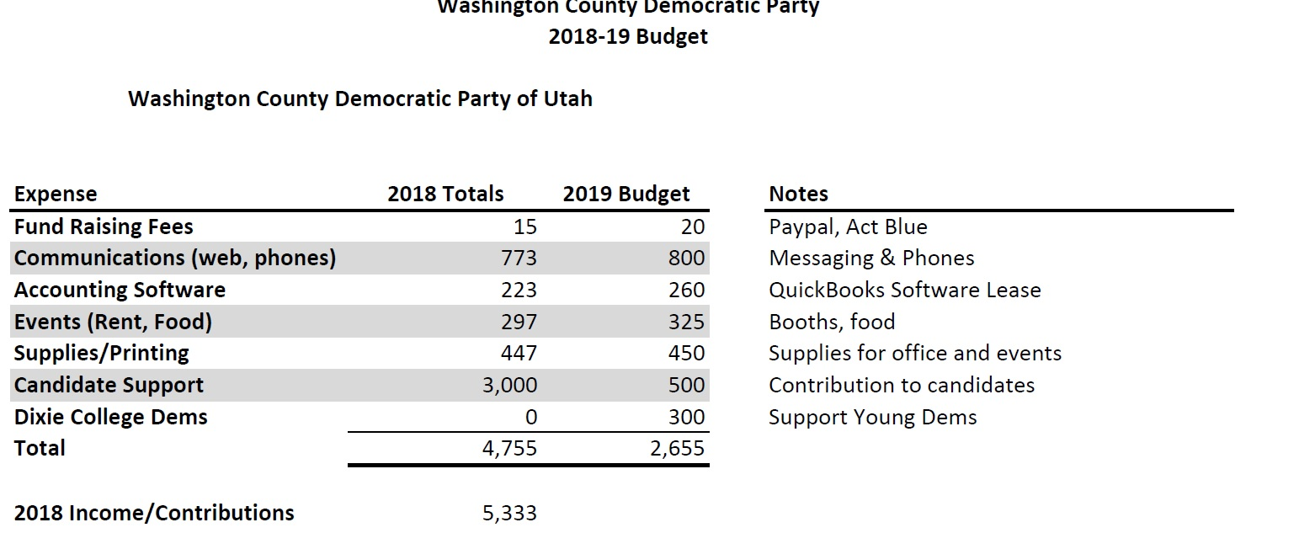

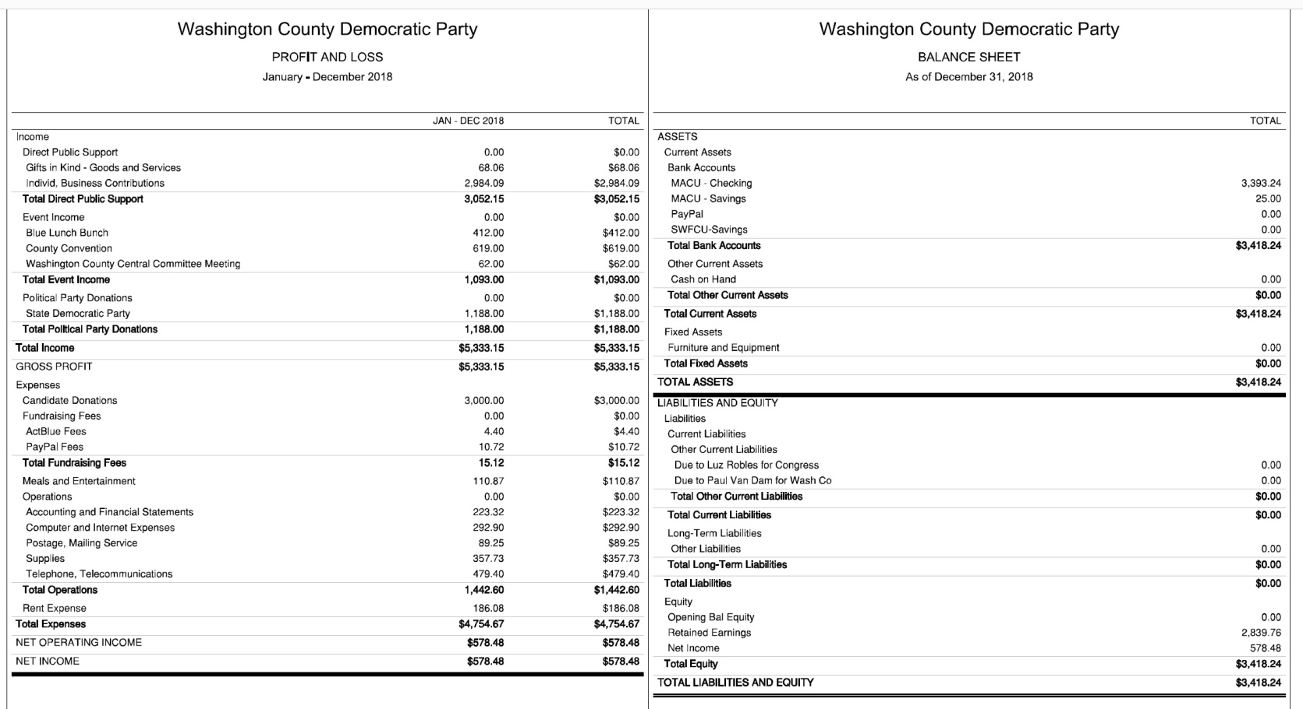

TO THOSE OF YOU WHO DONATE MONTHLY,
THANK YOU!

COLLIN WEISS, VICE-CHAIR
The most women ever elected at one time occurred in 2018
All local Democratic campaigns edged up to 25% rather than low 20's
Utah State legislature is now 25% Democratic and 20% women
Democrat Shireen Ghorbani received highest 30% against Chris Stewart
_______________________________________________________________
ABBY DOMAN, PRESIDENT, DSU COLLEGE DEMS

MEETINGS ON THURSDAYS IN THE GARDNER CENTER
STUDENTS ARE INVOLVED IN GUN CONTROL AND CLIMATE CHANGE ISSUES
_______________________________________________________________
DR ROBERT FORD

UPDATE ON CLIMATE CHANGE
UPDATE ON ENVIRONMENT -WATER, LAND AND AIR
_______________________________________________________________
CHUCK GOODE, CHAIR

UPDATE ON MEDICAID EXPANSION & PROPOSITIONS
UPDATE ON MEDICARE FOR ALL
________________________________________________________________
MEGAN HONER-ORTON, ZION CORRIDOR DISTRICT LEADER

UPDATE ON IMMIGRATION ISSUES
AND THE UTAH COMPACT
_________________________________________________________________
CHARLES STORMONT, STATE COMMITTEE

PAST CANDIDATE FOR UTAH ATTORNEY GENERAL
UPDATE ON STATE PARTY ACTIVITIES
_________________________________________________________________
Q DANG, SALT LAKE COUNTY PARTY CHAIR

CANDIDATE FOR STATE PARTY CHAIR OF UTAH
CONNECTING TO RURAL COUNTIES AND GETTING OUR MESSAGE OUT
___________________________________________________________________
KEYNOTE SPEAKER

DOROTHY ENGELMAN
PAST PARTY CHAIR, TAYLOR/MAYNE AWARD RECIPIENT, STATE EXECUTIVE COMMITTEE

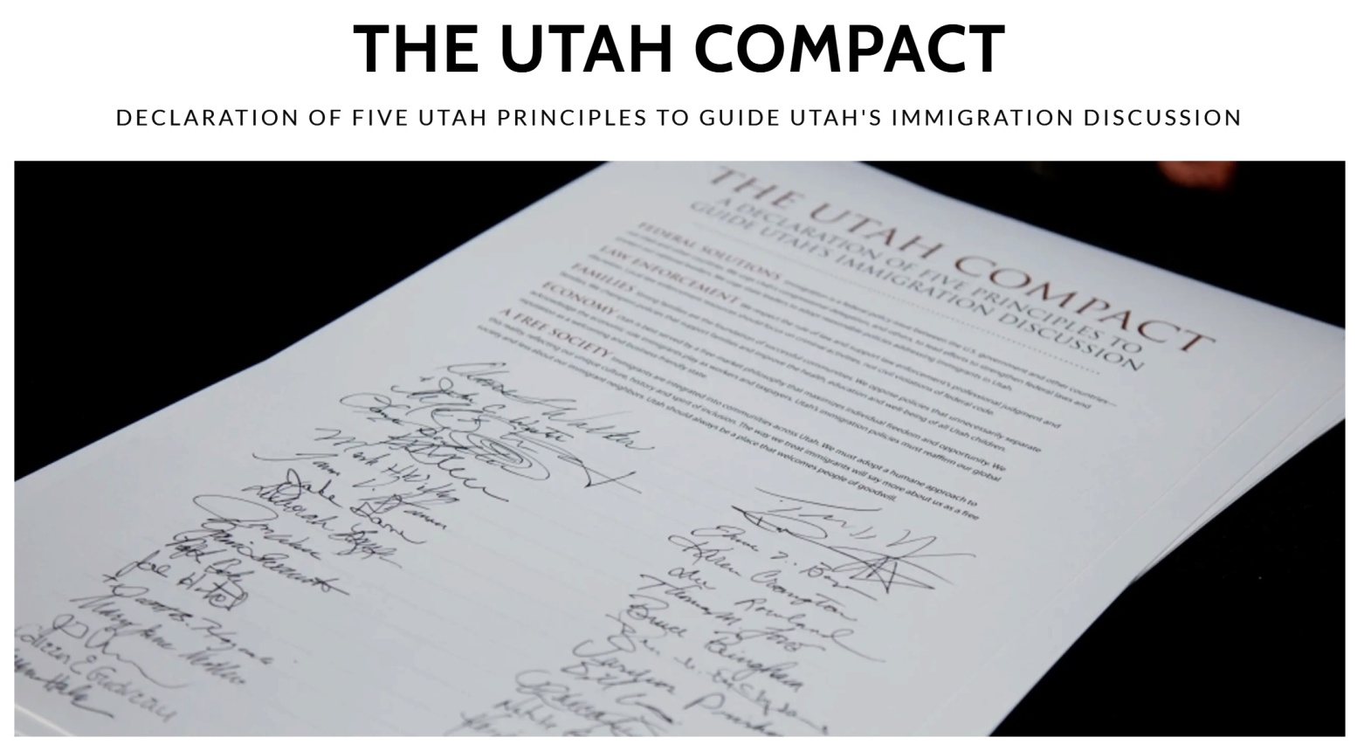The Utah Compact was developed over several months by groups and individuals who were
concerned about the tone of Utah’s immigration discussion. The Compact is based on Utah
values and we urge our leaders to use these guiding principles as they address the complex
challenges associated with a broken national immigration system. The Compact has broad support
from community leaders, business associations, law enforcement officers and members of Utah’s
religious community. It is a simple document that expresses our values as community as they
relate to specific policy issues that have become central to the immigration discussion.

THE UTAH COMPACT

FEDERAL SOLUTIONS Immigration is a federal policy issue between the U.S. government and other countries—not Utah and other countries. We urge Utah’s congressional delegation, and others, to lead efforts to strengthen federal laws and protect our national borders. We urge state leaders to adopt reasonable policies addressing immigrants in Utah.
LAW ENFORCEMENT We respect the rule of law and support law enforcement’s professional judgment and discretion. Local law enforcement resources should focus on criminal activities, not civil violations of federal code.
FAMILIES Strong families are the foundation of successful communities. We oppose policies that unnecessarily separate families. We champion policies that support families and improve the health, education and well-being of all Utah children.
ECONOMY Utah is best served by a free-market philosophy that maximizes individual freedom and opportunity. We acknowledge the economic role immigrants play as workers and taxpayers. Utah’s immigration policies must reaffirm our global reputation as a welcoming and business-friendly state.
A FREE SOCIETY Immigrants are integrated into communities across Utah. We must adopt a humane approach to this reality, reflecting our unique culture, history and spirit of inclusion. The way we treat immigrants will say more about us as a free society and less about our immigrant neighbors. Utah should always be a place that welcomes people of goodwill.

CANDIDATE PROFILES

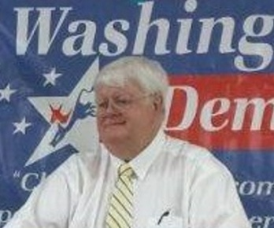
Chuck Goode: candidate for Chair of the Washington County Democratic Party. My political experience includes being the campaign manager for Dorothy Engelman in 2014 when she ran for HD74. In 2016 and again in 2018, I ran for Utah State House of Representatives in District 71. I moved to Southern Utah with my wife, Jean, after retiring as an Aerospace Software Engineer at NASA's Johnson Space Center in Houston, Texas. We loved the people of Toquerville and lived there for 25 years. We recently moved to St George and I have a deep involvement in this community. I was a leader in establishing St George Community Soup Kitchen at Grace Episcopal Church. This is a collaborative effort by all local churches serving needy families a hot meal five days a week. I served as a mentor to inmates in Purgatory Correctional Facility with addiction issues. I served as a Big Brother for BBBS, and sponsored an orphan girl from Brazil for 15 years through Christian Children's Fund.
I believe that we are in the midst of a critical transition in Utah's economic development. We are moving away from the agricultural and extraction industries. We can no longer depend on these industries to keep growing. We need to embrace the new technologies in energy, manufacturing and information. Technology is transforming education and healthcare. I dream of Utah leading the nation into this technological future and, maybe, bringing an end to our recurring social problems - poverty, hunger, suicide, addiction and domestic abuse. I know how to work with others and how to get things done. I believe people are more important than ideology. Too many Utahns are under-paid, under-insured and under-educated. We need to join together, focus our energy, recruit our friends and commit to fight for equality for all.

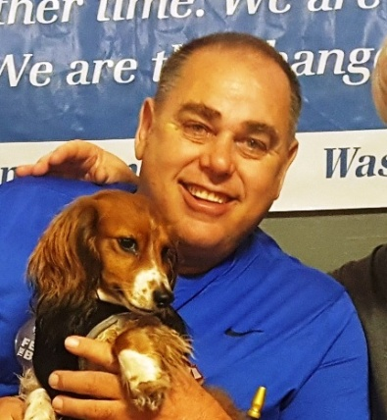
Collin Weiss - Candidate for Vice-Chair of Washington County Democratic Party. Served as Vice Chair 2018': Raised in Provo Ut. After graduating from Timpview High. Moved to Redlands, California. Studied at SBVC. Later moving to Anchorage, Alaska. Worked 10 years in the Arctic up in Prudhoe Bay in Construction support of the drill sites and pipelines. (400 miles north of the Arctic Circle). Joined Iron Workers Union Local 86 in Seattle, Wa. Where I took a leave from duties to care for my aging parents. (Hy & Mary in 2011/ S.G.). I've been involved in politics since Jimmy Carter. and barring my soul for principles of progressives thought since. I'm an Activist willing to walk the talk and be counted. Please join me in our endeavor with Washington County Democrats. "Democracy is not a spectator sport" Please join us and get involved.

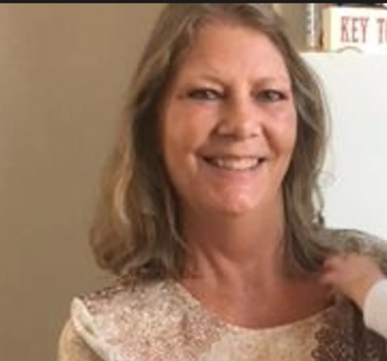
Jillynn Stevens, candidate for second Vice-Chair, is originally from Southern Utah but has lived in New York, New Jersey, Arizona, and a few other states. She is a social worker with an LCSW and also a PH.D. in social welfare policy. She has been an advocate and activist for over 30 years, promoting legislative and budget decisions that address the needs of underprivileged populations. Jillynn was active in the democratic party but took a hiatus after the 2016 election where she was a delegate for Bernie Sanders in Philly. She is a progressive and supports a bold agenda including The Green New Deal, Medicare for All, an end to war, and much more.

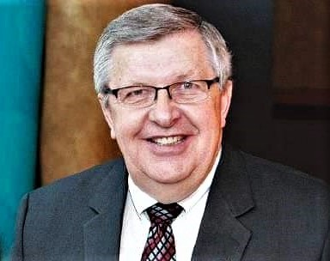
Charles Brokopp is a native of Wisconsin with a life-long interest in politics and state and federal service. He has held executive positions in both Democratic and Republican administrations in Idaho, Oregon, Utah and Wisconsin, and is an emeritus professor of population health sciences at the University of Wisconsin School of Medicine and Public Health. His educational training is in biology, laboratory sciences, public health and epidemiology. He has conducted public health research on including toxic chemicals, childhood lead poisoning, infectious diseases, and chemical and biological terrorism. He was responsible for managing annual program budgets between $200,000 and $44 million dollars. He served eight years on the board of a national laboratory association (APHL) including its President in 2013. In this role, he frequently met with congressional representatives and federal officials. He and his wife, Marilyn, retired from the University of Wisconsin, moved to Hurricane, UT in 2016, and have enjoyed getting to know many Democrats. He and Marilyn both served on the Utah Democratic Platform and Policy Committee during 2018-19. He is a candidate for Treasurer of the Washington County Democratic Party.
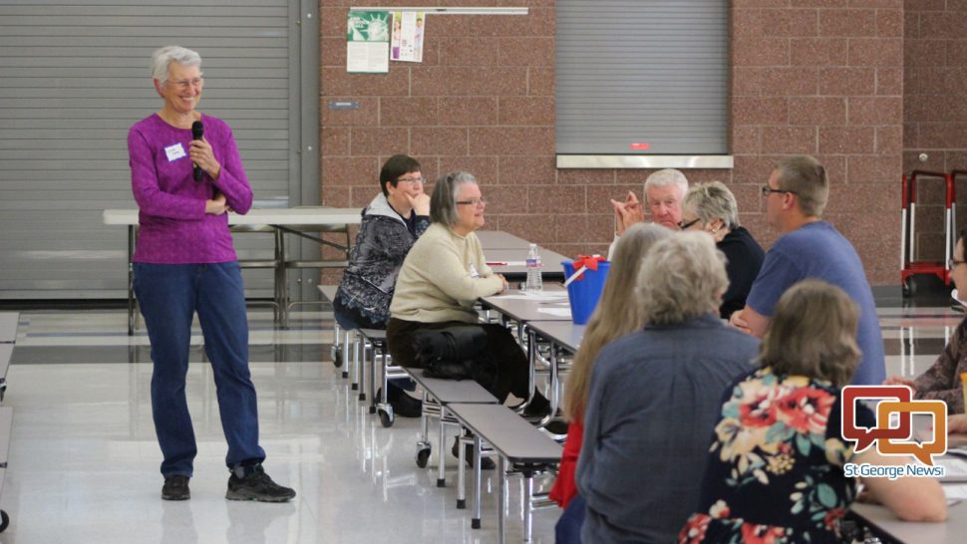
Lynne Cobb
Candidate for Secretary of the Democratic Party. Lynne Cobb is a clinical child psychologist, now mostly retired. Originally from the San Francisco Bay Area, she has lived in St. George since 2002. She and her husband, Bill, have two grown daughters and two grandchildren. Lynne's parents were New Deal Democrats.

WRITTEN BALLOT
WASHINGTON COUNTY DEMOCRATIC PARTY OF UTAH

EXECUTIVE COMMITTEE OFFICERS 2019 BALLOT

(CHECK ONE FOR EACH OFFICE)

CHAIR CHUCK GOODE ________________

FIRST VICE-CHAIR COLLIN WEISS ________________

SECOND VICE-CHAIR JILLYNN STEVENS ________________

SECRETARY LYNNE COBB ________________

TREASURER CHARLES BROKOPP ________________

UPCOMING EVENTS

TNT - Sunday evening,5:00 P.M. on March 24, 2019, TALK N TAPAS at the home of Sue & Ray Behle, 3038 Wesley Powell Drive, St George, Ut.

COE - Wednesday mornings, March 27th and every Wednesday at 8:30 a.m. and 9:00 a.m., CONVERSATION OVER EASY at George's Corner Restaurant in Ancestor Square

BLB - Saturday, April 20, 2019, BLUE LUNCH BUNCH at 11:30 a.m. at the Rib & Chop House on Convention Center Drive.

Friday & Saturday, June 21st & 22nd, UTAH STATE DEMOCRATIC CONVENTION
Park City High School in Park City
Visit UTAHDEMOCRATS.ORG for details
THANK YOU TO THOSE WHO SERVE SO WELL
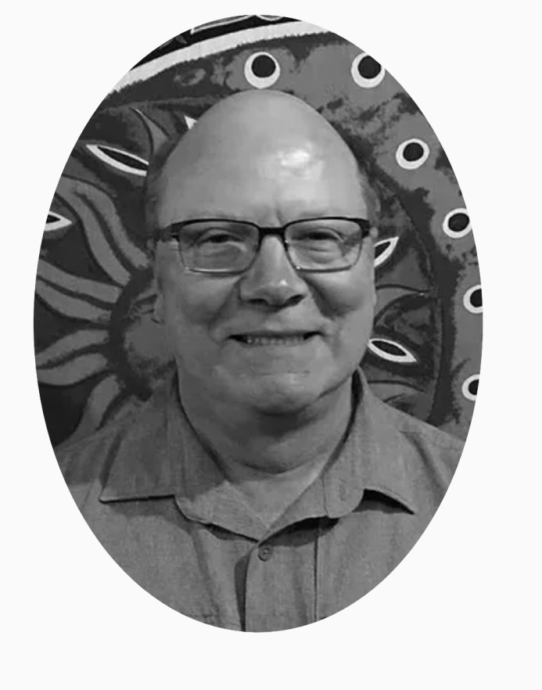

GLENN JUSTICE, TREASURER
2017-2019

THANK YOU FOR YOUR WISDOM AND YOUR DEDICATION
